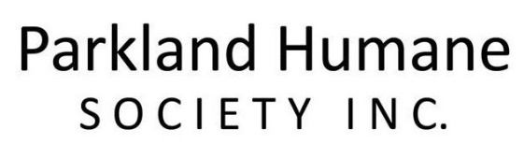

RELINQUISHMENT/ SURRENDER INFORMATION FORM

OWNER INFORMATION

Your name: _____________________________ Phone number: _____________________________

Address: _____________________________________________________________________________

DOG OR CAT INFORMATION

Dog or cat’s name: _____________________________ Breed: __________________________ _____

Age: ______________________ Sex: M or F Spayed / Neutered? _______________________

Coloring: ______________________________ Weight: _____________________________________

Known allergies, medications, medical conditions, etc: _______________________________________

_____________________________________________________________________________________

Why are you giving the dog or cat up? _____________________________________________________

_____________________________________________________________________________________

Are you able to foster your dog or cat until we can find them a home? YES or NO

If not, what is your deadline for relinquishing? _____________________________________________

Name / phone # of previous veterinary clinic : ______________________________________________

_____________________________________________________________________________________

Vet location and vet name: ______________________________________________________________

Dog Vetting History |  |  |  | Cat vetting history
Vaccination | Check If yes | Date of Last Treatment |  | Vaccination | Check if yes | Date of Last Treatment
Parvo / Distemper |  |  |  | Feline Distemper Combo
Rabies |  |  |  | Rabies
Bordetella |  |  |  | FIV test
Heartworm test & heartworm prevention |  |  |  | Heartworm test & heartworm prevention
Flea / Tick treatment |  |  |  | Flea / Tick treatment
Deworming |  |  |  | Deworming
Other |  |  |  | Other

Is this animal:

Potty trained? YES or NO

Used to being in a crate? YES or NO

Good with dogs? YES or NO

Good with cats? YES or NO

Good with kids? YES or NO

Have any temperament issues? YES or NO

Ever bitten/hurt someone? YES or NO

Overweight? YES or NO

Underweight? YES or NO

Had obedience training (Dog)? YES or NO

Crate Trained (Dog)? YES or NO

Jump over/dig under fences (Dog)? YES or NO

Additional Information: _________________________________________________________________

_____________________________________________________________________________________

_____________________________________________________________________________________

RELINQISHMENT AGREEMENT

(I/we) fully understand that by executing this document and delivering the above-described dog or cat to the Parkland Humane Society Inc., that (I/we) hereby relinquish any and all legal and equitable rights of ownership of the above-described dog or cat.

(I/we) represent that (I/we) are the lawful owner(s) of, and have good title to and the right and power to gift, sell, assign, transfer, convey and deliver said dog or cat; and that said dog or cat is free and clear from claims of ownership or other encumbrances of any kind or nature whatsoever by any person or entity.

(I/we) understand that Parkland Humane Society Inc. will act in the best interest of said animal in its care and placement. By assuming ownership, Parkland Humane Society Inc. reserves all rights in regards to making all decisions in regards to the dog or cat’s care, placement, and medical treatment.

(I/we) understand that Parkland Humane Society Inc. has the right to return dog or cat to owner if said dog shows aggression in the foster home and or shelter.

IN WITNESS WHEREOF, I have hereunto set my hand this _____ day of _________________, 20_____.

Signature: ____________________________ Name: __________________________________

SIGNED, AND DELIVERED IN THE PRESENCE OF: _____________________________________________

Parkland Humane Society Inc.
204-638-6966
P.O. Box 805
Dauphin, Manitoba
R7N 3B3

